**GROUP 2 MINI PROJECTS**

Members:

|  |  |  |
| --- | --- | --- |
| Full name | Tel. | Email |
| Nguyễn Xuân Trung | 0944353601 | [Trungnxqe170172@fpt.edu.vn](mailto:Trungnxqe170172@fpt.edu.vn) |
| Đoàn Nguyễn Huyền Trang | 0344468198 | trangdnhqe170154@fpt.edu.vn |
| Phan Phương Sinh | 0522991730 | [Sinhppqe170242@fpt.edu.vn](mailto:Sinhppqe170242@fpt.edu.vn) |
| Nguyễn Đồng Lợi | 0702772499 | loindqe170249@fpt.edu.vn |
| Đường Mỹ Hà | 0901130650 | [HaDMQE170046@fpt.edu.vn](mailto:HaDMQE170046@fpt.edu.vn) |

***PROJECT I – MUSIC BUZZER***

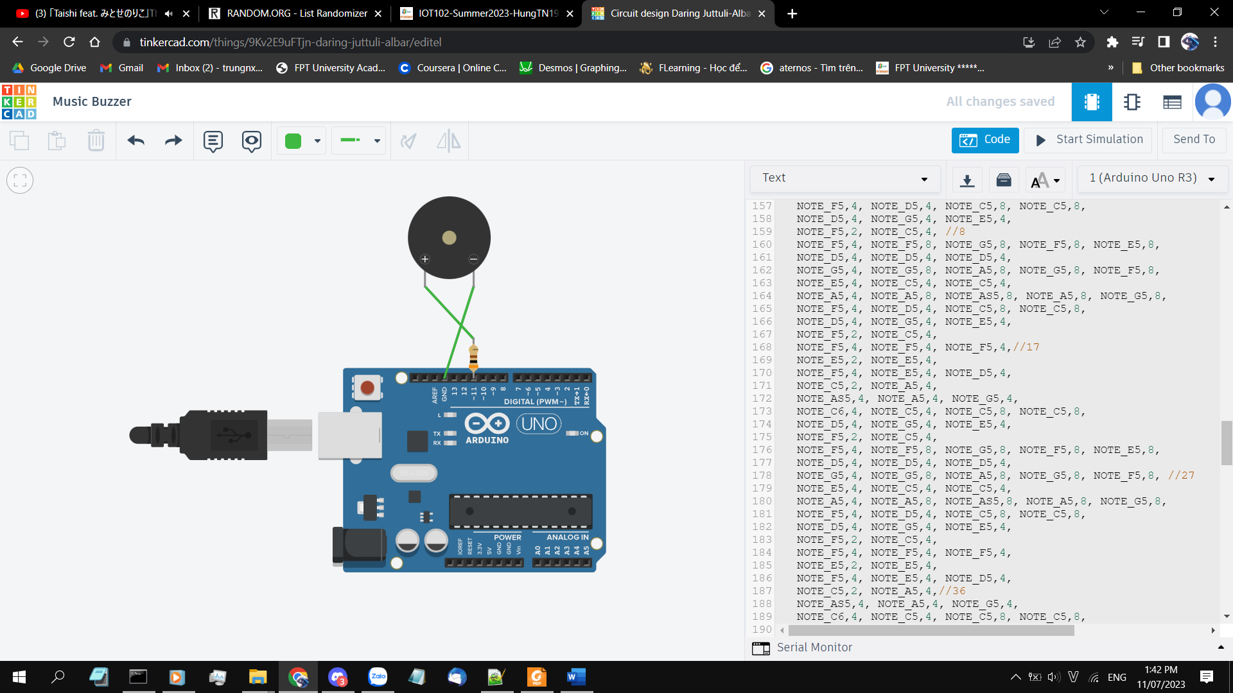

<https://www.tinkercad.com/things/9Kv2E9uFTjn-daring-juttuli-albar/editel?sharecode=SyOqPz1tyfR48fsHh5qjdxjVCwjvzuW3pKc-o8W9kYo>

This is a simple circuit that take advantage of how the Buzzer can play sound of different frequency. By using the constants that are the frequencies of musical notes, the code essentially turning the old plain buzzer into a music instrument.

There are three songs in the list, you can choose which song to play via the Serial input. All songs are hardcoded into the Arduino.

The buzzer need a resistor with a very specific resistance in order to play the note well. The huge wire-and-potentiometer contraption below is basically a glorified resistor as we cannot find a prebuilt resistor with that specific resistance.

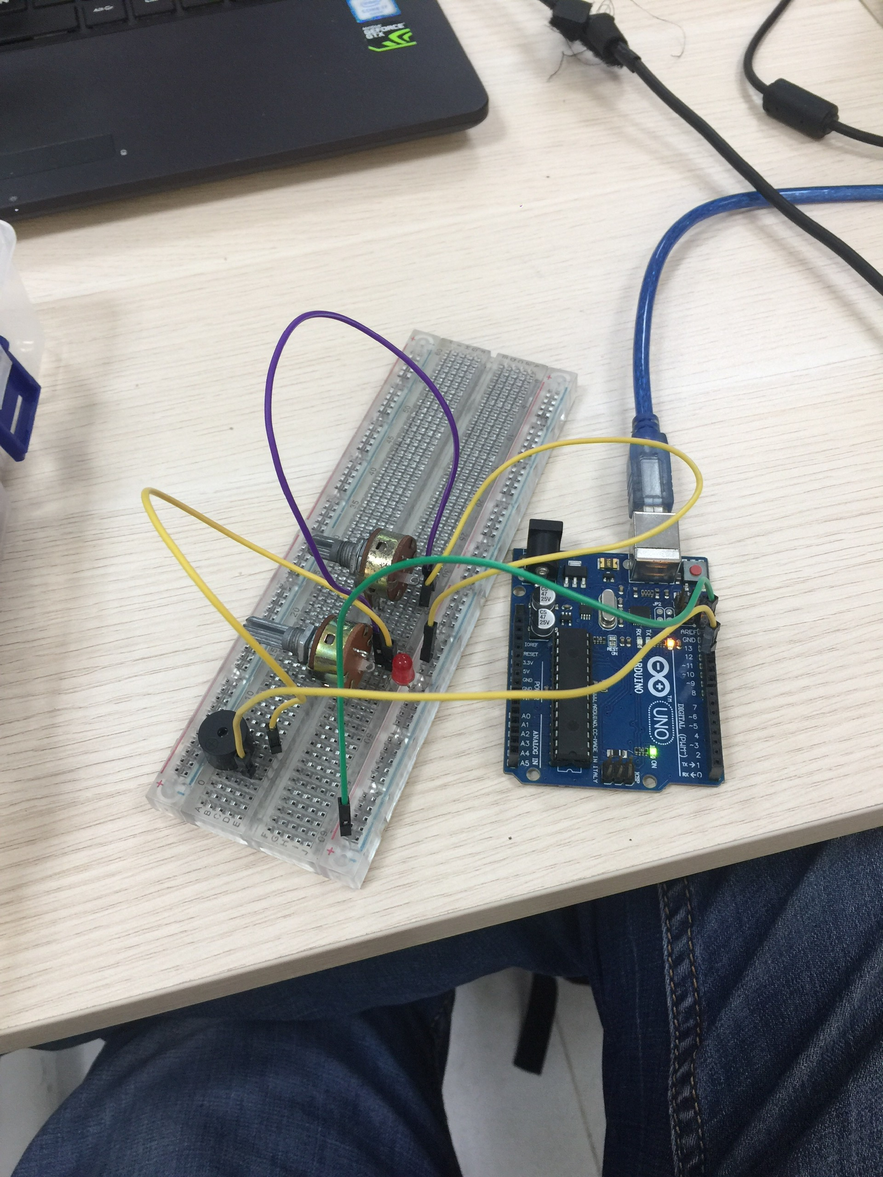

***PROJECT 2 – REMOTE CONTROLLED DOOR AND LIGHTS***

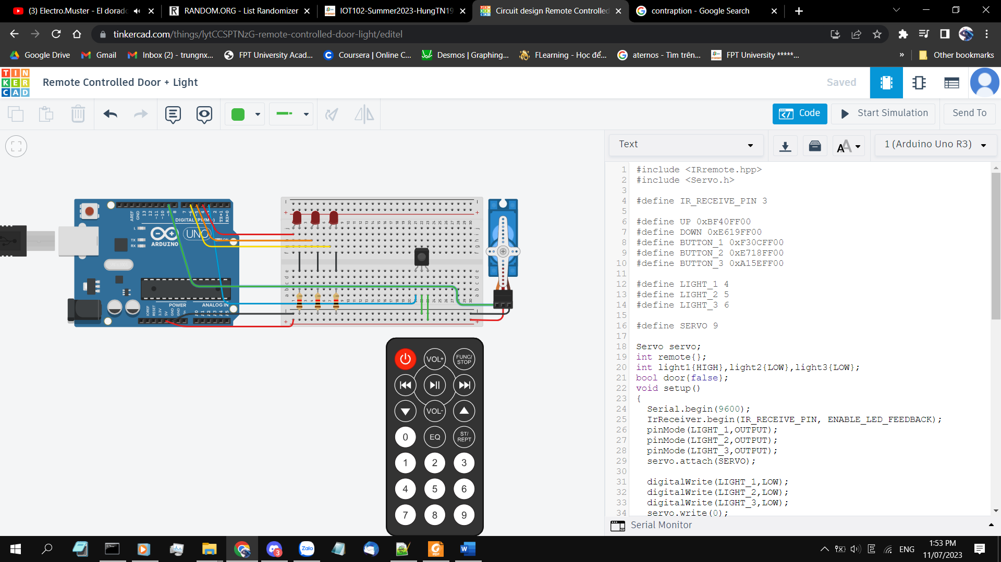

<https://www.tinkercad.com/things/lytCCSPTNzG-remote-controlled-door-light/editel?sharecode=fEaRK-usCt_BFd3mnvsyS2uraYwxoyBYJYO-EW8mAa4>

This is a circuit that uses a Infared remote control to control a servo motor and three different LEDs

The Irremote library that we used: <https://github.com/Arduino-IRremote/Arduino-IRremote>

The IR sensor can be configured to sense many types of remote. We have tried this with a TV remote, and it ran fine.

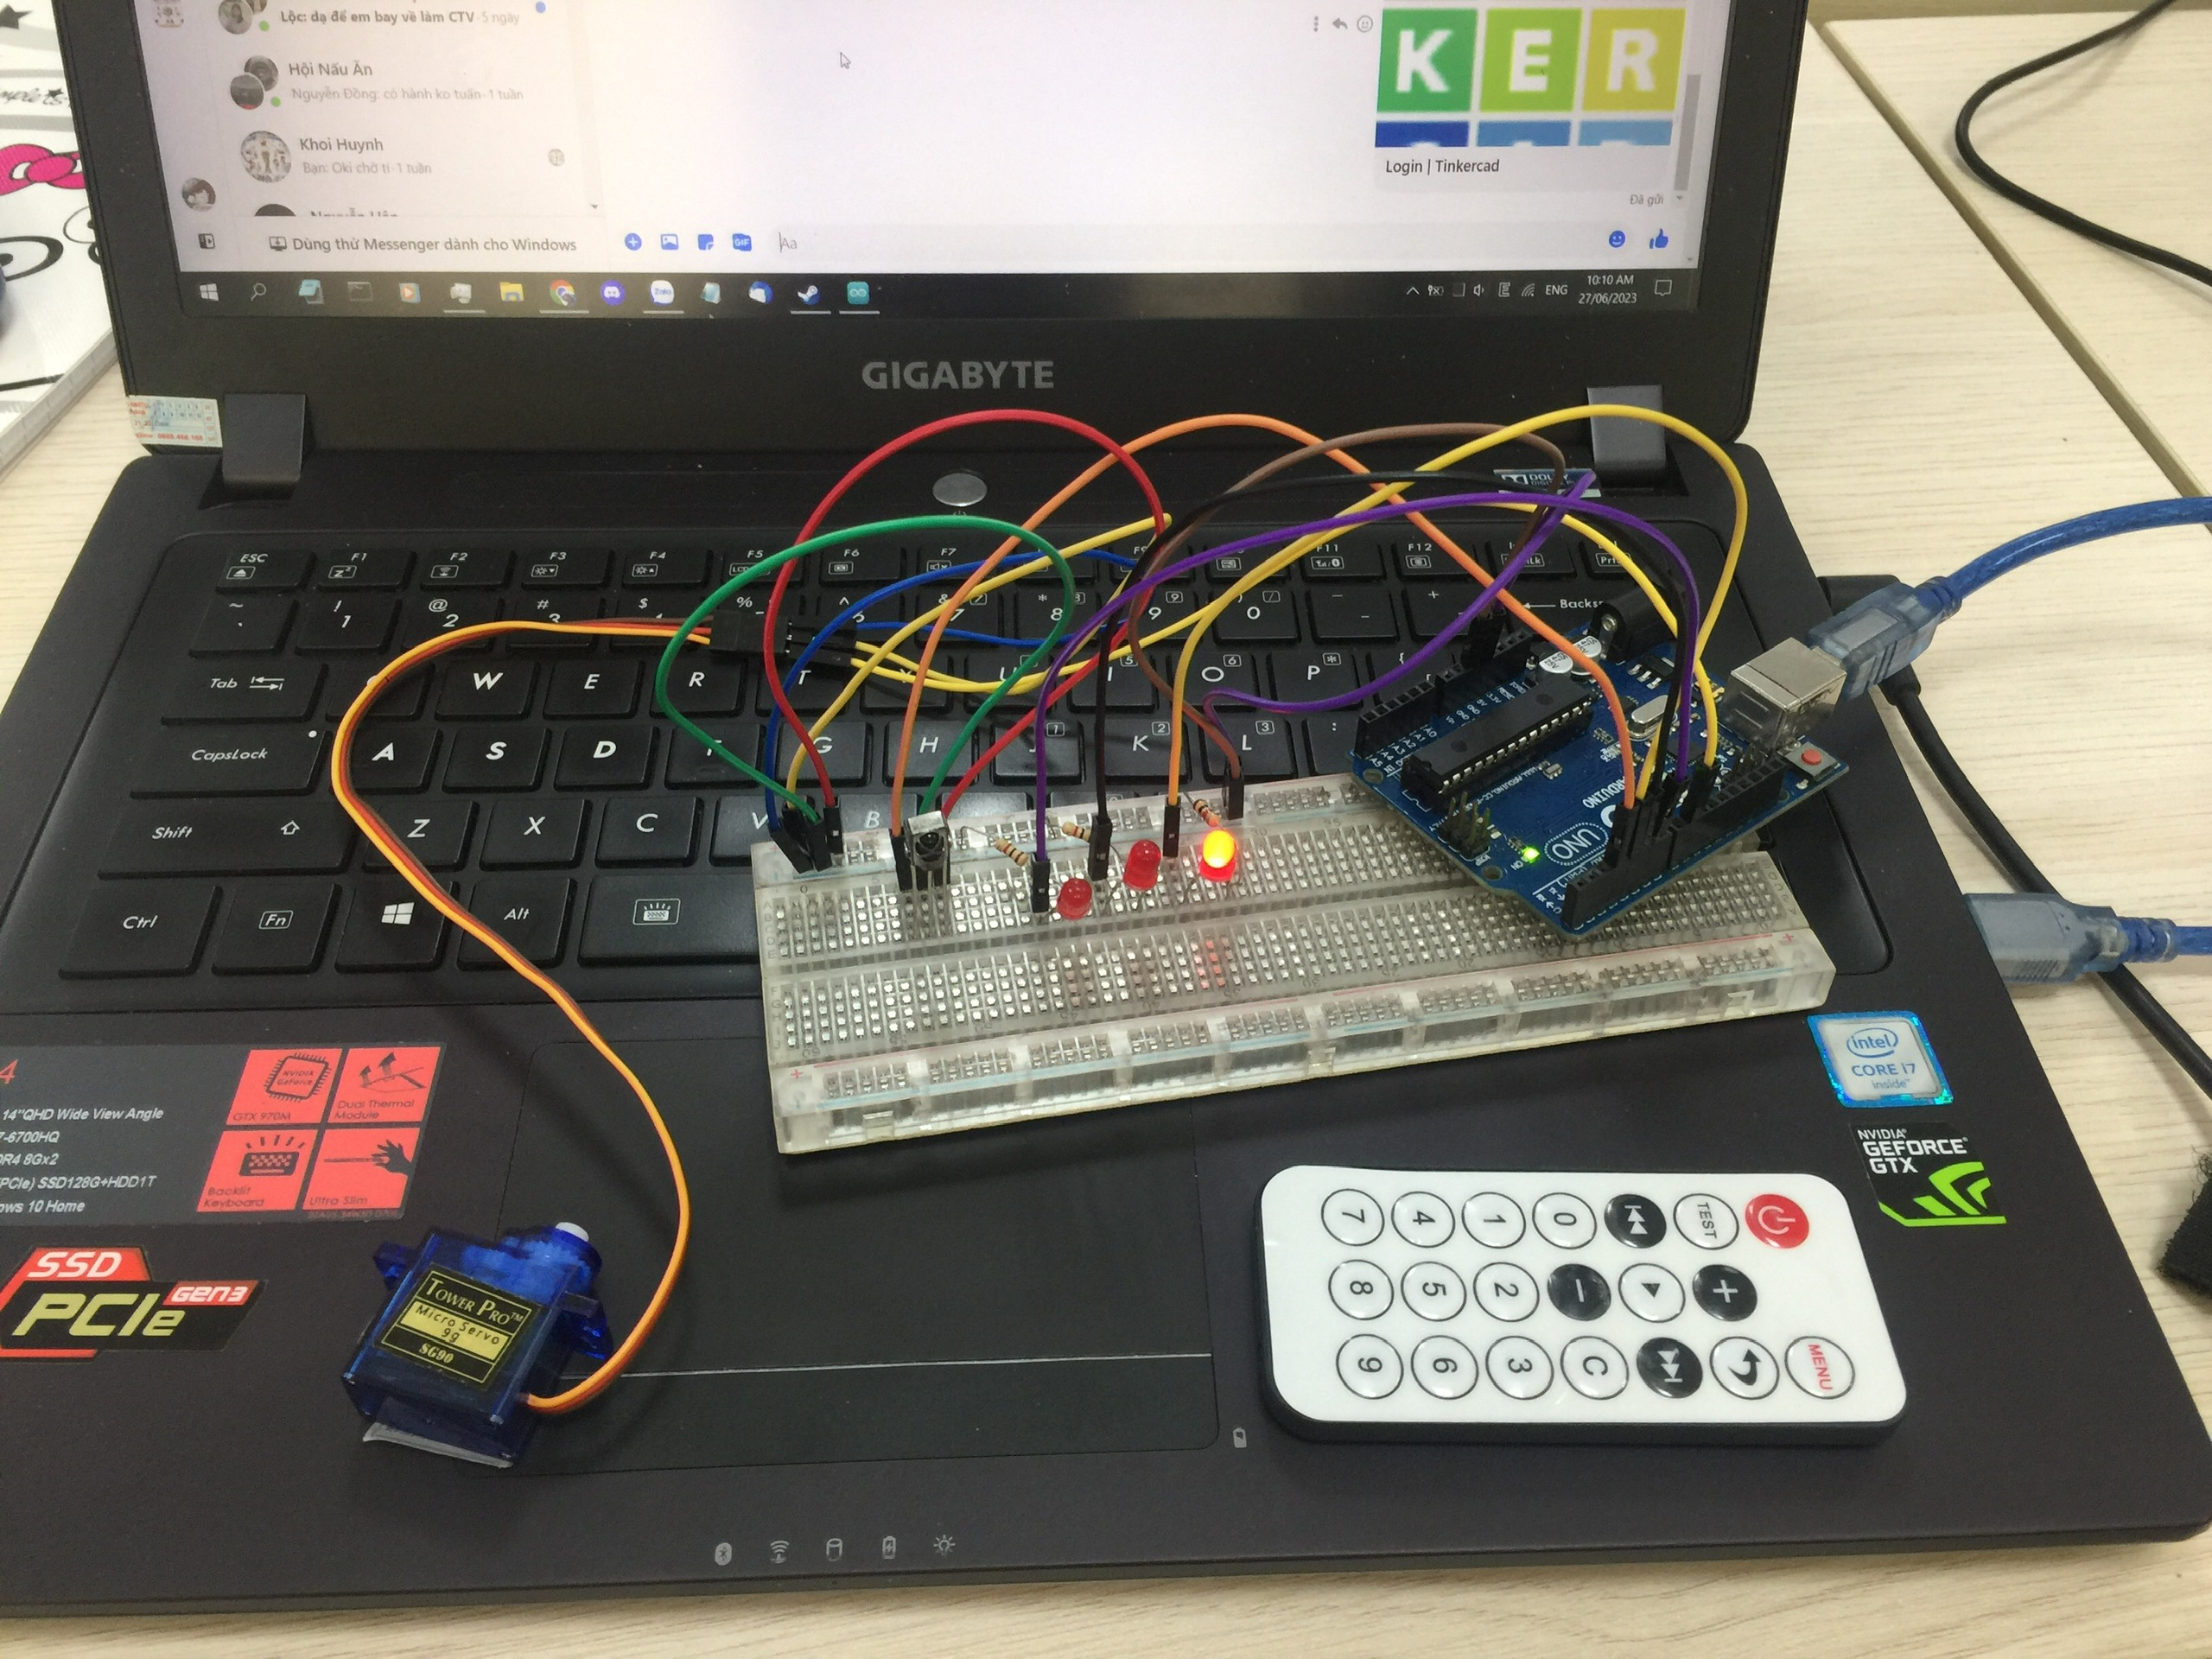

***PROJECT 3 – AUTOMATIC LIGHT WITH CALIBRATION***

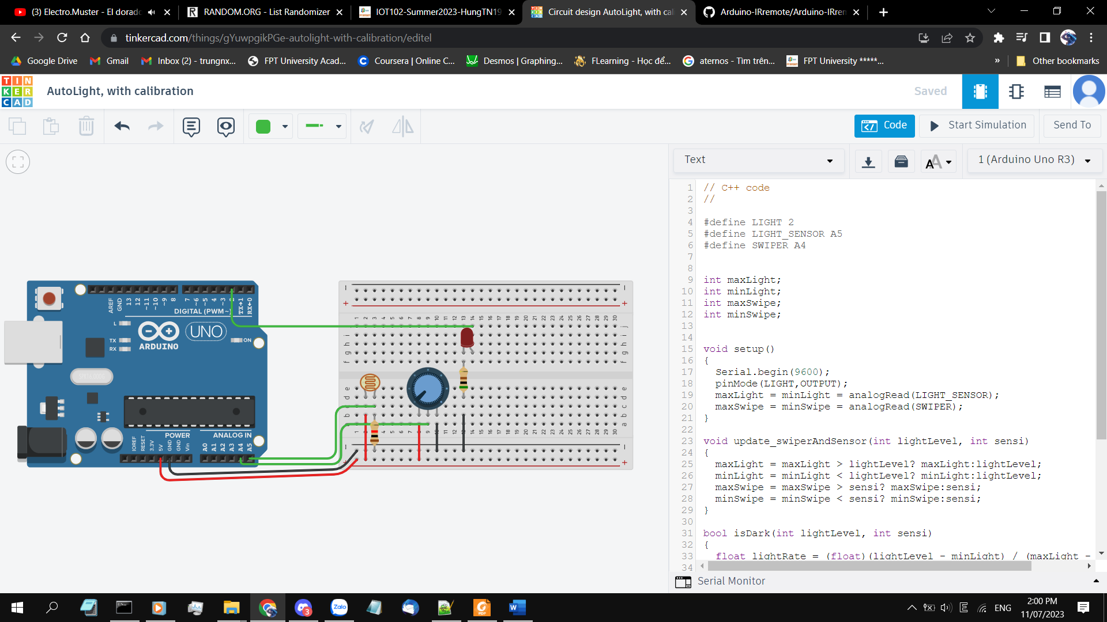

<https://www.tinkercad.com/things/gYuwpgikPGe-autolight-with-calibration/editel?sharecode=HKW7mMR5_bOMYlYB0vxhxBxF1gLm8GWdPLrcGw9dfAc>

This circuit used a photosensor to determine the light level and a potentiometer to change the sensor’s critial point. Whenever light level go below critial point, the light will turn on, it will turn off when light level is higher than the critical point.

The circuit will remember the light sensor’s “range” – its highest and lowest value while in used, and changes the potentiometer’s range accordingly. In a sense, this circuit will “adapt” to where it is used, no manual calibration needed.

